**CAPE LAB – ASSIGNMENT 1**

***21CH30028 – SAYAN GHOSH***

**Problem Statement:**

A 100kmol/hr feed consisting of 10, 20, 30, and 40 mole% of propane, n-butane, n-pentane, and n-hexane, respectively, enters a flash chamber at 105psia and 200F. The flash drum (Flash2) operates at 100psia and 200F. Applying the ‘IDEAL’ property method, compute the composition of the exit streams.

**Flow-sheet:**

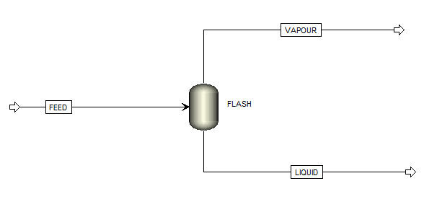

**TABLE:**

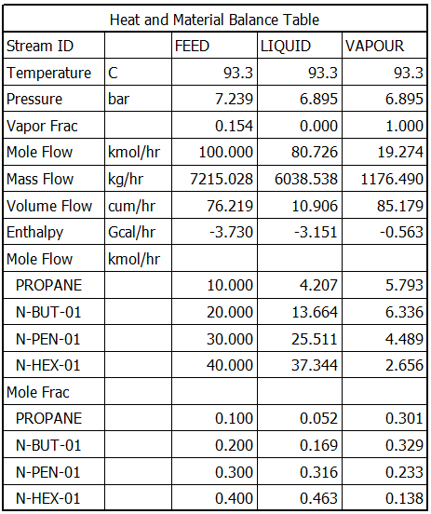

**Answers:**

|  |  |  |
| --- | --- | --- |
|  | **LIQUID STREAM** | **VAPOUR STREAM** |
| **PROPANE** | 0.052 | 0.301 |
| **n-BUTANE** | 0.169 | 0.329 |
| **n-PENTANE** | 0.316 | 0.233 |
| **n-HEXANE** | 0.463 | 0.138 |